Module 1: Communication
Task 1: Build your Resume
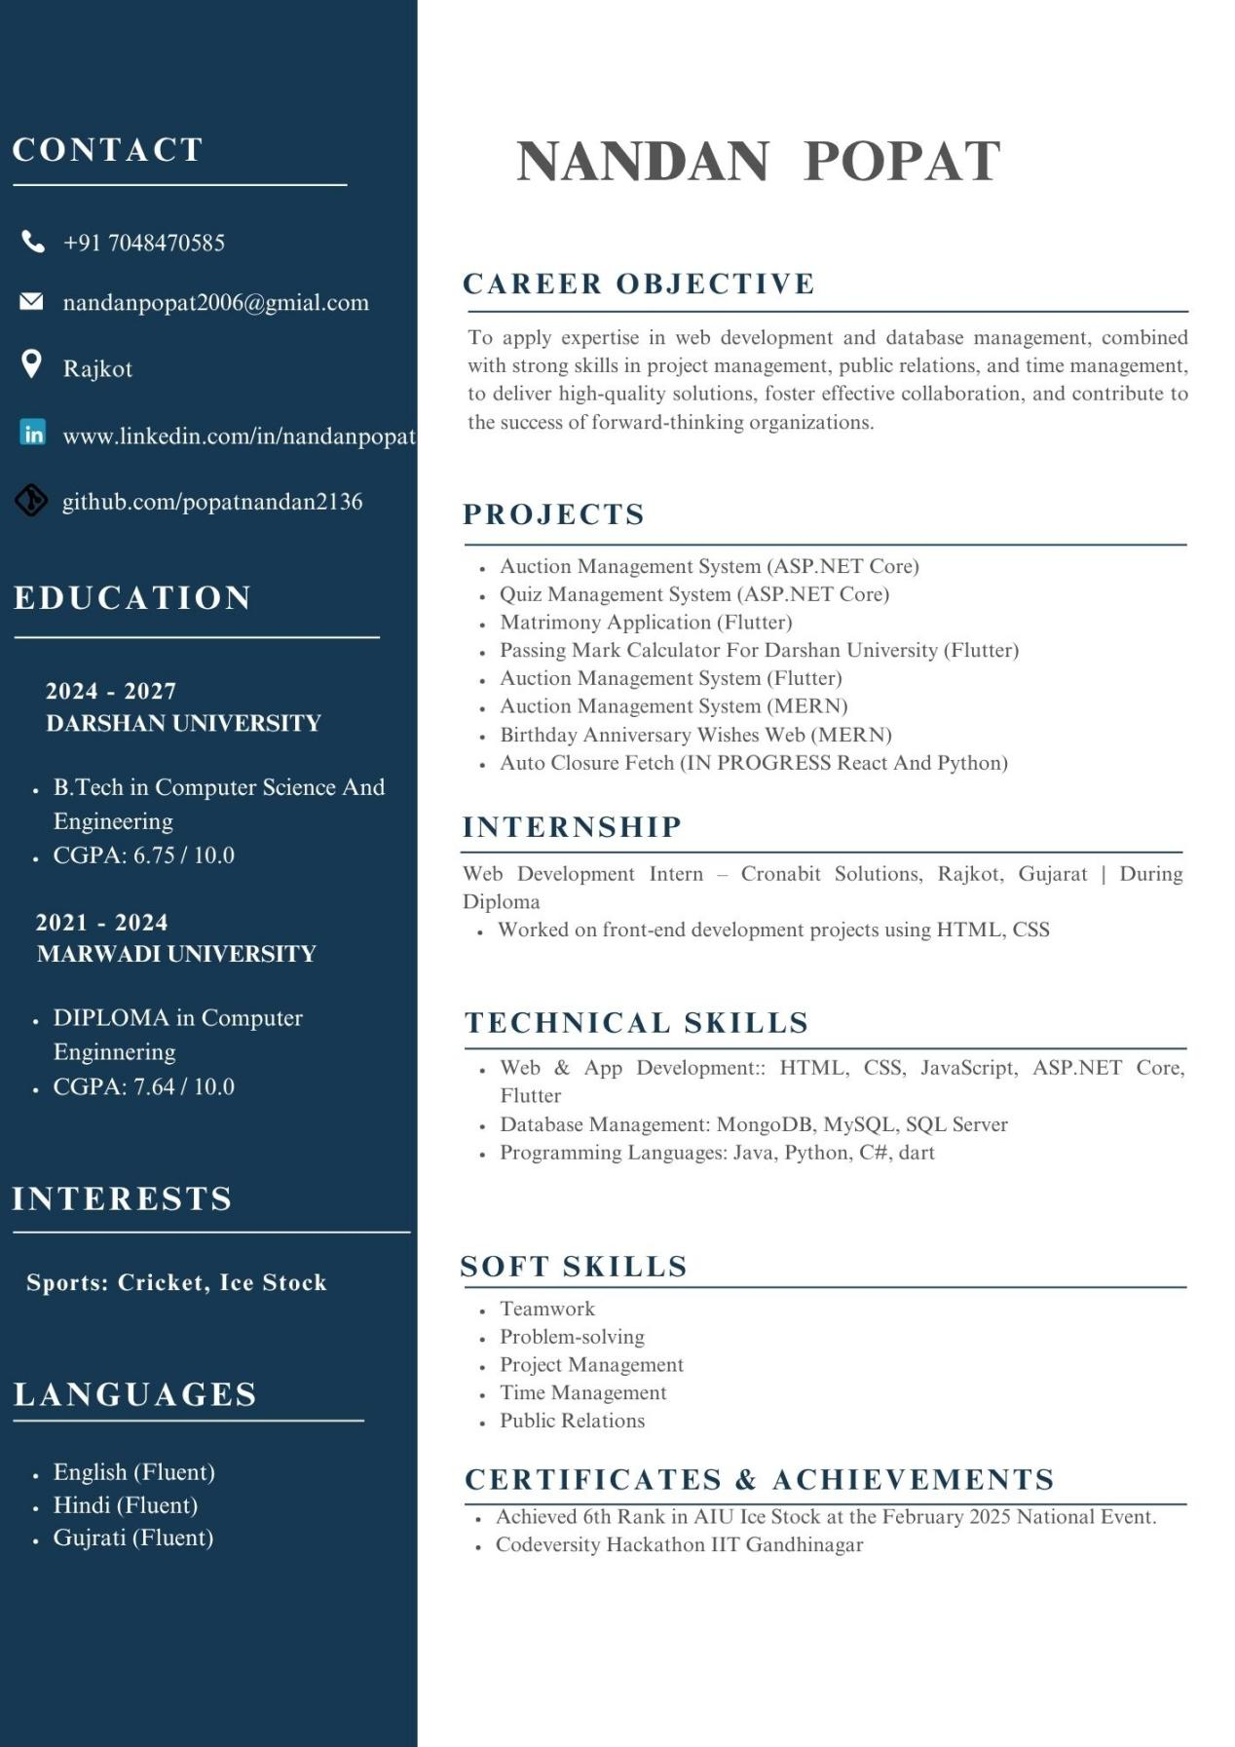

Task 2: LinkedIn Profile
https://in.linkedin.com/in/nandanpopat

